Post-Cutover to Interval Billing Level Set Workshop

Meeting Minutes

Location: | CR P10-050C Bridge: 17038652981 Conf Id:22309505 | Date: | 2/4/2014
Chair(s): | Ganesh Ponnadurai | Time: | 1:00 – 4:00PM

Participants
Attendee | Attend | Phone | Regrets | Attendee | Attend | Phone | Regrets
Amanda Gomez |  |  | X | DAVID VERBERKMOES |  |  | X
Amit Jadli |  |  | X | Dean Martin |  |  | X
Amy A. Masud |  | X |  | Deborah Harworth |  |  | X
Anand Shwarnam |  |  | X | Deborah L. Sleight |  | X
Anthony Fava |  |  | X | Doug Mckay |  |  | X
Asha Sreedharan |  |  | X | Douglas A. Schultz |  | X
Beth Fields |  |  | X | Elizabeth White |  |  | X
Bradley D. Herson |  |  | X | Elizabeth White |  |  | X
Brian Ingram | X |  |  | Eric Engel |  |  | X
Brian Simmons |  |  | X | Ganesh Ponnadurai | X
Carol Demlow |  |  | X | Gerald Wyse |  |  | X
Carrie Harkness |  | X |  | Glenn P. Barba |  |  | X
Chad Conrad |  |  | X | Gregory Holliday |  |  | X
Chaitanya Kodela (CK) |  |  | X | Harikrishnan Bhanu |  | X
Charles(Chuck) Debruler |  |  | X | Harinder Braich |  |  | X
Cheryl Reimer | X |  |  | Hayden L. Shepherd Jr |  |  | X
Cheryl Whiting |  |  | X | Hope Navarro | X
Clark Oeler |  |  | X | Idan Goldbroom |  |  | X
Curtis Rine |  |  | X | Ivan Principe |  | X
Dave Khuong |  |  | X | Jack W. Hobbick | X
Dave Koerkel | X |  |  | James West |  | X
Jana Terry |  |  | X | Nick Bourne |  |  | X
Janice Kincaid | X |  |  | Nilabja Guha |  |  | X
Jayakumar Chinnusamy |  |  | X | Ninos Ziazadeh |  |  | X
Jeanne Showalter | X |  |  | Nitish Walia |  |  | X
Jeff Yankley |  |  | X | Olubunmi Adenuga |  |  | X
Jeffrey Tolonen |  |  | X | Padmaja Talluri |  |  | X
Jessica Scott | X |  |  | Patricia Onelio |  |  | X
Josh Walker |  |  | X | Patrick Ennis |  |  | X
Kaiser Dandangi |  |  | X | Pete Hirth | X
Keith Axtel |  |  | X | Phillip(Phil) O. Ranoni |  |  | X
Kennard Reeves |  |  | X | Phyllis A. Scheffel |  | X
Kent Hea |  |  | X | Prashant B. Gupta |  |  | X
Kurt Guenther |  |  | X | Praveen Jettipalle |  |  | X
Kyle Harris |  |  | X | Rachael Brege |  |  | X
Lego Kwapa |  |  | X | Ramana Gedela |  |  | X
LINDA GRIMM |  |  | X | Ramesh Swarna |  |  | X
Lori France | X |  |  | RK Madan |  |  | X
Lori Meyer |  |  | X | Robert Gray |  |  | X
Luis Arcienega | X |  |  | Robin Lesher |  |  | X
Makund Thaker |  |  | X | Ryan Walker |  |  | X
Manoj Ajgaonkar |  | X |  | Sally A. Scripps |  |  | X
Marinus Grootenboer |  |  | X | Saurabh Agrawal |  |  | X
Mark A. Good |  |  | X | Scott Tingle |  |  | X
Mark Luoma |  |  | X | Stephanie Messer | X
Mark McCollum |  |  | X | Stephen Lee | X
Mark Ortiz |  |  | X | Stephen Russell |  |  | X
Melanie Faibish | X |  |  | Stephen Stubleski |  |  | X
Michael Holden |  |  | X | Steve Rogers |  |  | X
Michelle Brock | X |  |  | Steven Wilson |  |  | X
Naresh Vatte |  |  | X | Sue A. Hines |  |  | X
Thomas Clark | X |  |  | Tyler Doehr | X
Thomas O'Reilly |  |  | X | Volker Herrmann |  |  | X
Tim Voss | X |  |  | William Reetz | X
TIMOTHY WALLBAUM | X |  |  | Zachary J Pakkala | X
Timothy(Tim) A. Brewer |  |  | X

Agenda

Agenda Item | Topic | Presenter
1 | Opening Remarks | Ganesh P.
2 | Who’s Here (Roll Call) | All
3 | Review R4 Blueprinting Process | Ganesh P.
4 | Review Topics and Business Owners | Ganesh P.
5 | Review Scope and Assumptions | All
6 | Identify Deep Dive Processes | All
7 | Confirm Deep Dive Participants | All
8 | Review Captured Requirements | Stephen Lee
9 | Review Action Items | All
10 | Wrap Up and Next Steps | Ganesh P.

Meeting Notes

Agenda Item 1: Opening Remarks
- Stated primary purpose of workshop is to establish the scope for subsequent Post-Cutover to Interval Billing Deep Dive
Agenda Item 2: Who’s Here (Roll Call)
- See above list for attendance
- Asked if anyone is missing from the meeting that needs to be present to have a productive workshop
  - Response: All groups needed are present

Agenda Item 3: Review R4 Blueprinting Process
- Review the blueprinting process and the differences between R3 and R4
Below is the blueprint process for R4
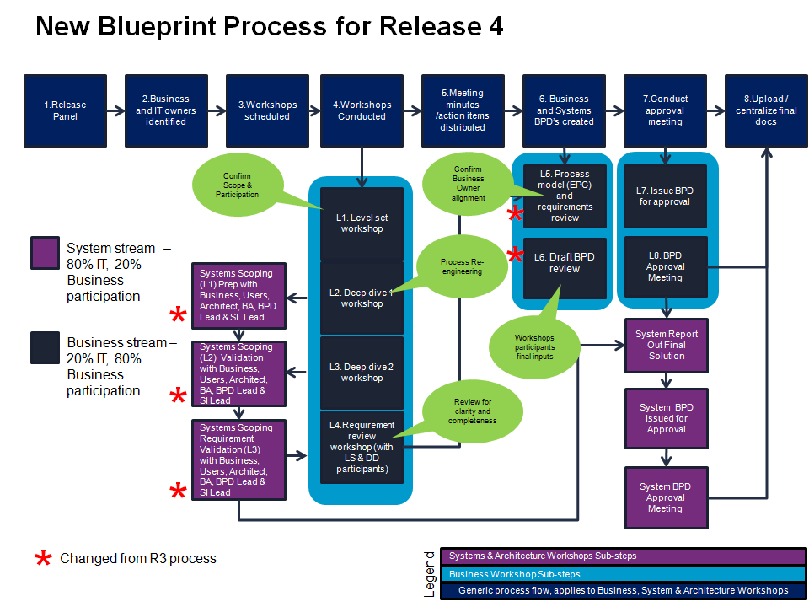

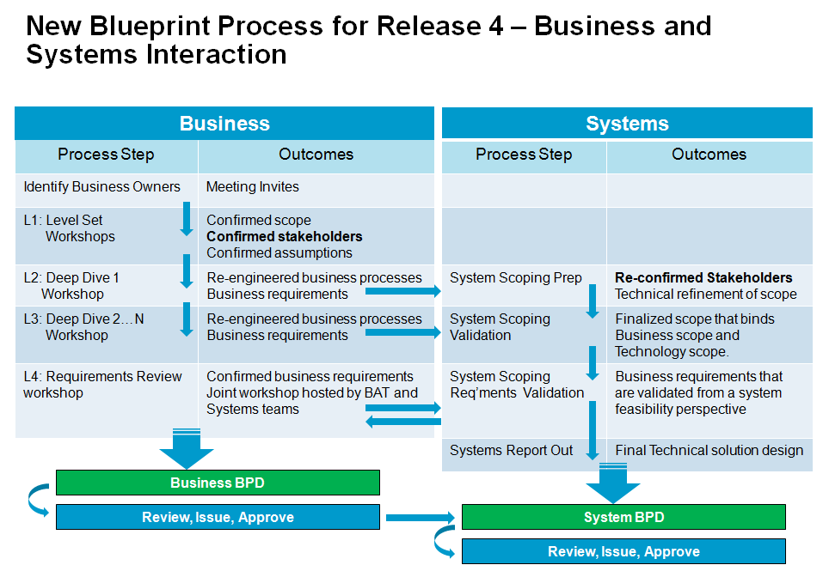

Agenda Item 4: Review Topics and Business Owners
- Zach Pakkala is the Business Owner for this topic
  - Doug Detterman and Marsha Perry will be removed from the invite lists for subsequent workshops (they will remain as formal approvers)

Agenda Item 5: Review Scope and Assumptions

Scope
High Level In-Scope Considerations
- Interval Reads – Residential and C&I (Commercial & Industrial)
- Consumption vs. Index
- Max Demand (Interval)
- Power Factor (Interval)
- It was noted that all residential and commercial & industrial customers that have intervals stored in MDM have AMI meters
- It was noted that only max demand and power factor will move to interval reads for billing
- No residential customers will use interval billing in R4 (it is anticipated that interval consumption reads for Residential will be covered in R5 when Time Of Day rates will be introduced)
- Any customer with AMI meters will have interval reads
- Single Phase meters are on 60 minute intervals (with a select group on 15-minute intervals) – C&I only for R4
- Polyphase meters are on 15 minute intervals
- Read Rate Analysis
- Special Non-Billing (i.e. Read-Only) meter reads are taken for Rate Analysis
- Both max demand and power factor based reads are used for rate comparison and analysis
- This analysis helps determine if customer need to move to a new rate category (e.g. GS to GSD)
- ACTION: A foucus group meeting will be arranged to look at the changes around this analysis involving interval reads now available
- Direct Load Control - Residential and Small Business
- Currently load control customers are on an index rate
- Interval billing is available to customers who bill OTA and any customer that signs up for a program requiring interval billing
- For the future, 15 minute intervals will be needed in R5
- Meter Reading & VEE
- This will be required for interval OTA billing
- Gap Fill & Estimation
- This will be required for interval OTA billing
- This needs to be explored further with the MV90 customers
- Customer Enrollment - C&I
- Max demand
- Power Factor
- Opt-Out - Residential and C&I
- Need to consider process for going back to manual reads and legacy meter for an existing AMI (interval) meter
- Need to upload interval meter data before swap
- Billing Preparation & Presentment - Residential and C&I
- Index reads and usage currently billed
- Move to interval now involves recorded estimated/actual/total data
- What constitutes estimated vs actual interval?
- How to present information on the bill and how to show the differences?
- Non MV90 customers on AMI intervals – what to do with those customers?
- Index is presented with line items showing total and estimated meter reads and graphic of historical usage
- Do we still need to show index (like MV90)?
- Do we need to show actual, estimated and total recorded consumption on the invoice (like we do with MV90 customers)?
- Billing Determinants & Validations - Residential and C&I
- Recorded usage vs. index
- MDM uses index reads to compare against recorded intervals
- Is gap-fill switched off in OWCE and MDM? Need to explore
- Customer Billing Enquiry - Residential and C&I
- Need to explore customer enquiry process for potential changes
- AMI Meter Deployment (Cutover) – NOW BACK IN SCOPE
- Transition from Index-based reads vs. new interval reads for read verification
- Validating kWh registers (changes to CARS)
- Cancel/Re-Bill (aka. Reverse/Re-Bill)
- Residential and C&I – IN SCOPE
- No Process Change

Out of Scope for This Workshop
- Gas Metering & Estimation
- Customer Enrollment & Outreach Channels for DLA & DPP
- Electric or Gas Register Billing
- Customer Selects Due Date (for Bill)
- TOU – Residential and C&I
- On/Off peak or High/Med/Low
- Consumer Portal - Residential and C&I –
- It was decided to have an offline conversation with Zach Pakkala to discuss further details
- Index rate customers still get interval view on portal
- PayGo Program
- Data Recovery in the HE
- Meter Reading Schedule
- Theft Detection (impacting Billing)
- Outage Management (impacting Billing)
- Remote Turn-On/Offs (impacting Billing)
- Net Metering (impacting Billing)
- Needs 15 min interval reads
- PEV (Plug-In Electric Vehicle)
- ODR (On Demand Read) will always be index based
- Customer Selection - Residential and C&I
- Only for programs that require interval data
- R4 will only focus on C&I customers
- Customer Migration - Residential and C&I
- Cutover for max demand/power factor from manual to interval OTA
- Moving residential from index OTA to interval OTA based on program enrolled
- AMI Meter Deployment (Cutover/Route Closure/HQ Turnover)
- R4 will only focus on C&I customers

Assumptions

Scope Assumptions
- Effected Population & Rate Considerations
  - Small commercial customers are GS and GSD and customer choice rates
  - Large commercial customers are GP, GPD and customer choice rates (generally billed off MV90 metering)
  - Are there any other rates to consider?
    - Response: Rate analysis for customers who request rate comparisons

Listed below are the different types rate codes discussed in the workshop.
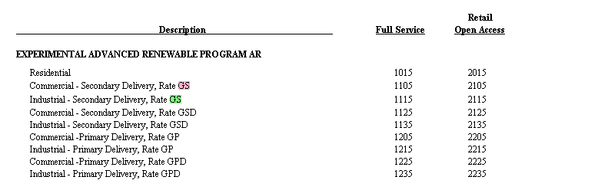

  - There are 9,000 single phase meters (residential) single phase billed on a demand tariff; Do we plan on having the 9,000 meters pre-programmed for Interval OTA?
  - Complex billing determination is more complicated for Ccommercial & Iindustrial (C&I) customers
  - What are we targeting for these C&I customers - i.e. MV90 or SAP EDM + real-time pricing? This may translate to an increase in degree of difficulty!!!
    - ACTION: This is a question for the BP Policy Meeting.
  - Eliminating MV90 to replace with IEE-MDM may not happen, but objective is to minimize MV90 ; Anticipate low volume for “gas” functions, high revenue customers and security issues will keep MV90 from being completely eliminated
  - Changes to functional groups require a meter swap (OTA config group/function -- Meter program)
  - Changes are required to the technical master data within both SAP and IEE support the interval billing process, namely the creation (ties to install/remove/replace processes), allocation to the register, and replication of interval “profiles”
  - How do we handle the change of rate meter configurations?
  - What is the rate assignment process for move-in/move-out situations?

- Interval Data Needs
  - Business Rule: Interval Data will be stored in the MDM for 84 months
    - Discussion on timeframe of how long to store data in the MDM
      - How often do you need access to the data? Is it for Archive or immediate access?
        - Response: 3-year billing for real-time access
      - NOTE: 3 years is not to be acknowledged as the corporate storage policy
  - 60-Minute intervals for Residentials; 60 or 15 -minute for Commercial & Industrials not billing on demand
    - Single Phase meters used for some C & I customers will use a 15 minute interval
    - 9K customers use GSD
    - 60 minute intervals CANNOT be used for Demand Billing
    - Can we use 60-min for rate analysis?
      - Response: Currently rate analysis is performed monthly, therefore 60 minutes will be sufficient
        - Is this in Grid Director, SAP or ACT?
  - 15 minute intervals for Commercial & Industrials required for demand based rate categories (i.e. max demand or power factor billing)
  - Are we officially going to send demand and kVARh reads for ALL C&I accounts?
    - Needs to be clarified based on further rates analysis
  - Business Rule: Nothing less than 15-minute intervals for any customer, unless special category created
  - Business Rule: There are limitations of up to 7 meter registers in the Openway HE
    - NOTE: Not all registers are needed

- Validation & Verification
  - Does MDM know the difference between missing read and a corrupt read?
  - Interval limitation in MDMS implies 4 validations types for single phase and 20 for polyphase ( GE) ???
  - ITRON recommends using a limited number of validations for R4 based on the number of resources currently available within MDM; hence few validation checks were selected
    - Discussed that the existing models must comply with the current MV90 Calculations – Compliance (MPSC)
  - High/Low MAY be done – but decision is not yet final!
  - Is there a conflict that may exist with the validation rules within SAP and those of MDM?
  - Best way to handle this is not to turn on power outage – Would like to make sure we can utilize outage notification for ALL meters that can talk to us
    - Response: IEE puts a status on the intervals
  - Gap-fill interrogation (an extension of VEE), will need to be turned on for interval billing
  - What does Consumers do with meters that have stopped communicating?
    - Response: There needs to be a backup plan for collecting intervals (Field Tools?)

- Billing Determinants & Rate Considerations
  - Appropriate SAP and IEE rate configuration changes may be needed, development of formulas are required to allow for interval billing determinant requests
  - The existing deployed meters have register channels that are pre-programmed according to the current TOU time periods and thereby Consumers Energy has some flexibility with respect to how many TOU rate categories are migrated over to using interval data as part of the billing calculations (NOTE: TOU is in R5)
  - Complex billing determination is performed in MDMS with distinct determinants back to SAP billing system (for interval billing) Why is this only for residential customers?

Out of Scope Assumptions
- Time of use is supported through on/off registers
- Clarified Time of Use is for C & I customers
- Clarified Time of Day is for residential customers
- R5 Multiple TOUs scheduled, based on the rate (On-peak, mid-peak, off-peak) will be through different registers
- Gas communications module won’t be deployed until Q3 2014 and this is with Centron via Openway and assuming not through TMS
- Customer Selection Considerations
- Rate Codes
- TOD – Time of Day is for R5
- TOU – Time of Use (Total Monthly Category) is for R4
- Interval Demand Eligibility Rules
- Customer has a value added need for it
- Meter type available
- Interval Consumption Only Eligibility Rules
- Customer has a value added need for it
- Meter type available
- Customer Segmentation
- Customer Acquisition Process
- Outreach
- Qualification
- Conversion/Migration
- Retention

- Customer Migration Considerations
- Cutover Targets
- Less important than validation and strong communication targets
- Enrollment Wave Calendar
- Not sure this has been defined yet
- Enrolled Meter Counts by Headquarter/MRU
- Validation met – 1 month or 2 months?

Agenda Item 6: Identify Deep Dive Processes
- Presented list of meter process models created/updated during Release 3 and legacy process models
- Asked workshop participants to review list and identify any processes not shown in the list that they believe may be relevant to the Load Control Devices/Switches
The embedded file contains the VACD for Post-Cutover to Interval Billing

- Provided a link to participants showing the hi-level process model in ARIS Business Publisher, from which all detail processes can be accessed as needed; will be provided in meeting minutes. (Note: must have access to CE’s intranet site in order to access these read-only models.) Process models can be printed, saved as a PDF file, or e-mailed (via the printer icon above an opened process model)

This embedded file contains link and instructions on how to access print, e-mail, or save a file of a process model in ARIS Business Publisher

Agenda Item 7: Confirm Deep Dive Participants
- Identified participants in Level Set workshop that will not be attending the Post-Cutover to Interval Billing Deep Dive
  - Michelle Brock and Cheryl Reimer not available
- Identified participants not invited to Level Set workshop that will be invited to the Pre-Cutover to Interval Billing Deep Dive:
  - Tim Brewer
  - Cheryl White

Agenda Item 8: Review Captured Requirements
NOTE: These requirements are in DRAFT mode. They are not final and are subject to modification and/or deletion. Do not use these requirements for design.

This embedded file contains the list of the requirements captured during the meeting
.

Agenda Item 9: Review Action Items
- The action items captured are shown in the log below:

Action Item Log
Item  Ref # | Action Item Description | Due Date | Status | Owner | Comments
POST_01 | Discuss difference between the MDM’s ability to pull the current month maximum demand vs. the need for an on-peak demand (GSD rate categories all utilize the current month maximum demand (need to verify case of the 60% clause) |  | Closed |  | No on peak demand needed
POST_02 | Need to have a detailed architectural discussion around what “complex” billing determinants will be calculated by the MDM. We have invested over 15,000 hours (rough estimate) in the complex EDM billing configurations in SAP. There are significant doubts that the MDM can replicate these determinants. Need to also review direction of adding such significant replication of effort when we have other options. |  | Defer | SE Core Team | Moved to BP Policy Meeting Discussion
POST_03 | What happens in the case where the MDM doesn’t have anchor reads, and there are missing intervals? How is the ending index going to be generated? | 2/7/2014 | Open | Pete Hirth, Cheryl Reimer, Tim Wallbaum | MDM will estimate the missing interval.  How will the 3-day window work with interval billing?
POST_04 | Need to discuss the need for EDM profiles for true interval billing. This is not necessary for R4, but it is my understanding that it is a requirement for R5? | 2/7/2014 | Open | Zach Pakkala | Related to MV90 SAP/MDM configuration  IEE needs rates table for this change
POST_05 | Should Grid Director be considered for Rate Analysis? | 2/7/2014 | Open | Dave Koerkel | What data needs to be stored in both single phase and polyphase?
POST_06 | Performance tests: Test the OTA meter progress change: 60 min to 15 min. | 2/7/2014 | Open | Jack Hobbick | Collecting requirements for performance tests  New Installer/Rate Change

Agenda Item 10: Wrap Up and Next Steps
- Next workshop will be on Thursday 2/6

